**Acropolis Institute Of Technology And Research,**

**Indore (M.P.)**

****

**Subject – Database Management System (DBMS)**

**(CY-405)**

**Name – Tanvi Bhawsar**

**Enrollment No. - 0827CY221063**

**Branch - CS(Cyber Security)**

**Semester - 4th  (2nd year)**

**Submitted To – Mrs. Nidhi Nigam Ma’am**

**Index**

|  |  |  |  |  |
| --- | --- | --- | --- | --- |
| **Sr. No.** | **Experiment** | **Date of Exp.** | **Date of sub.** | **Grade** |
| 1. | To study DBMS and RDBMS, its characteristic comparisons and study of popular DB software. | 11/03/24 | 18/03/24 |  |
| **2.** | To study of Mysql ,features of my sql and installation of mysql. | 01/04/24 | 08/04/24 |  |
|  |  |  |  |  |
|  |  |  |  |  |
|  |  |  |  |  |
|  |  |  |  |  |
|  |  |  |  |  |
|  |  |  |  |  |
|  |  |  |  |  |
|  |  |  |  |  |
|  |  |  |  |  |
|  |  |  |  |  |

# **LAB WORK 2**

**INTRODUCTION OF MYSQL ,FEATURES OF MY SQL AND INSTALLATION OF MY SQL**

## **What is MySQL?**

**MySQL** is an**open-source, Relational Database Management System** that stores data in a structured format using **rows** and **columns**. It’s software that enables users to **create, manage**, and manipulate databases. Developed by **MySQL AB**, which is now owned by **Oracle** Corporation, MySQL is renowned for its reliability, scalability, and ease of use.

**FEATURES OF MYSQL**

Here are some key features and aspects of MySQL:

1. **Open Source:** MySQL is [open-source](https://www.geeksforgeeks.org/introduction-to-open-source-and-its-benefits/" \t "_blank) software, which means it’s **free to use** and has a large community of developers contributing to its improvement.
2. **Relational:** MySQL follows the relational database model, allowing users to organize data into **tables** with **rows** and **columns**, facilitating efficient **data storage** and retrieval.
3. **Reliability:** MySQL has been around for a long time and is known for its **stability** and **reliability**.
4. **Performance:** MySQL is optimized for performance, making it capable of handling **high-volume transactions** and large datasets efficiently.
5. **Scalability:** MySQL can scale both **vertically** and **horizontally** to accommodate growing data and user loads. You can add more resources to a single server or distribute the workload across multiple servers using techniques like [sharding](https://www.geeksforgeeks.org/what-is-sharding/" \t "_blank) or [replication](https://www.geeksforgeeks.org/data-replication-in-dbms/" \t "_blank).
6. **Compatibility:** MySQL is widely supported by many **programming languages**, [frameworks](https://www.geeksforgeeks.org/what-is-a-framework/" \t "_blank), and tools. It offers connectors and [APIs](https://www.geeksforgeeks.org/what-is-an-api/" \t "_blank) for popular languages like PHP, [Python](https://www.geeksforgeeks.org/python-programming-language/" \t "_blank), Java, and more, making it easy to integrate with your existing software stack.
7. **Security:** MySQL provides robust **security features** to protect your data, including access controls, encryption, and auditing capabilities. With proper configuration, you can ensure that only authorized users have access to sensitive information.

## **Applications of MySQL**

MySQL has used in various applications across a wide range of industries and domains, because of to its versatility, reliability, and performance. Here are some common applications of MySQL:

1. **E-commerce:**MySQL is extensively used in e-commerce platforms for managing **product catalogs**, **customer data**, orders, and transactions.
2. **Content Management Systems (CMS):** Many popular CMS platforms rely on MySQL as their backend database to store **website content**, **user profiles**, comments, and configuration settings.
3. **Financial Services:** MySQL is employed in **financial applications**, including banking systems, payment processing platforms, and accounting software, to **manage transactional data**, customer accounts, and financial records.
4. **Healthcare:** MySQL is used in **healthcare applications** for storing and managing **patient records**, medical histories, treatment plans, and diagnostic information.
5. **Social Media:** MySQL powers the backend databases of many social media platforms, including **user profiles**, posts, comments, likes, and connections.

# **Installation of MySǪL on Windows**

In this tutorial, we are installing the latest version of MySQL (8.0.34) on

Windows 11. Follow the given steps to do so −

**Step 1:** Firstly, choose the MySQL version and operating system. Then, we download the desired MSI installer on your system by clicking the 'Download' button shown in the image below. This installer is suitable for both 32-bit and 64-bit systems.

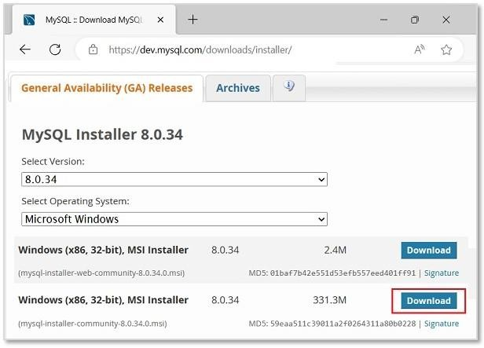

**Step2:** Then, we will be redirected to another file download page. Here, ignore the prompts asking to log in or sign up and directly start downloading by clicking on the link as shown in the image.

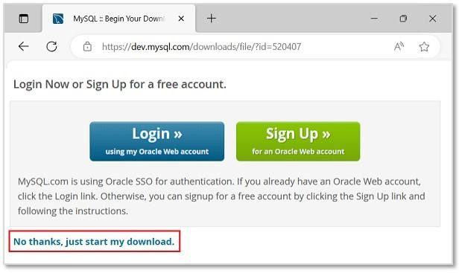

**Step 3:** Once the installer is downloaded, run it to start the MySQL installation.

**Step 4:** Now, we can see the installer community window, asking to choose a Setup type for our MySQL products. Choose **Custom** and click **Next** to decide what products we want to install.

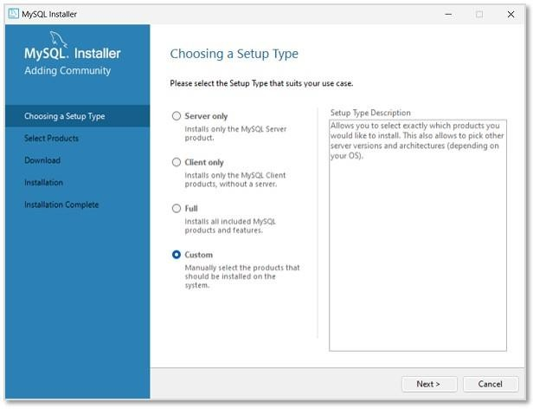

**Step 5:** In the next step, select MySQL Server, MySQL Workbench, MySQL Shell (all latest versions) to be installed. We can also choose more products available as per necessity.

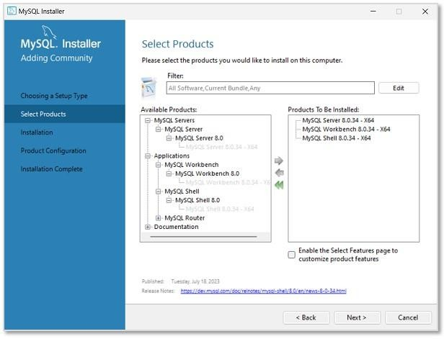

**Step 6:** The installation process will now begin. However, path conflicts might arise if there exists a path directory with the same name. After the installation is done

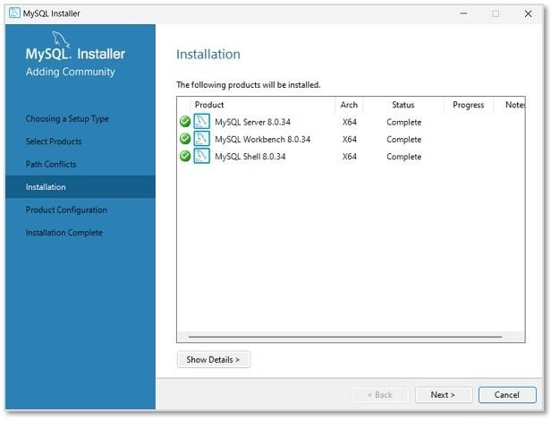

**Step 7:** In this step, we will be asked to set Type and Networking of MySQL. Unless there is any particular change we want to make, it is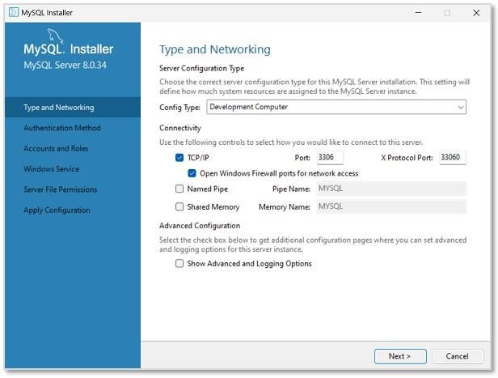recommended to keep the settings as they are.

**Step 8:** Then, we need to set the Authentication method to access MySQL root user. So, choose the strong password encryption method .

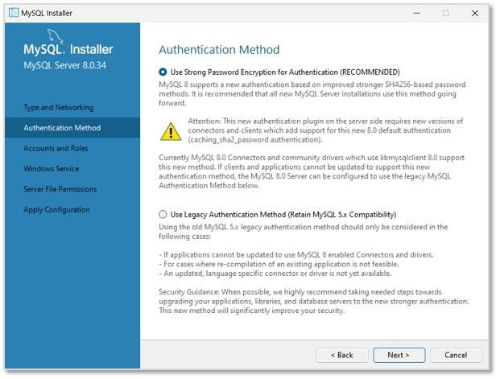

**Step 9:** Set a password for the root account. This password must always be used to log into the root account in every session. After setting password

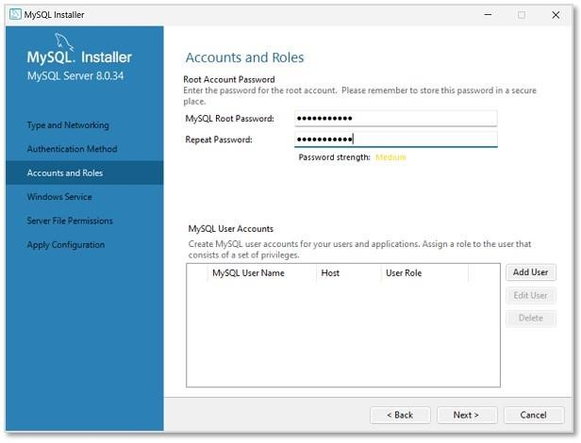

**Step 10:** In this step, MySQL Server Instance will be configured as a Windows Service. The default name will be set as "MySQL80", which can be changed if needed

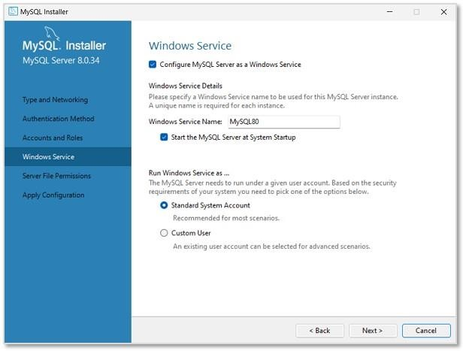

**Step 11:** Now, set the file permissions as required and click **Next**.

**Step 12:** As shown in the image below, the specified configuration steps will be applied on clicking **Execute**.

**Step 13:** The installation is now complete. Uncheck the options asking to start MySQL Workbench and Shell after setup, so that they will not run after setup. Click **Finish**.

